**Enable or disable site collection features**

Microsoft SharePoint lets you enable and disable site collection features that determine everything from the use of workflows to the online help collection that should be available to users. Most site collection features are turned off by default, but you can easily change that.

**To enable or disable a site collection feature**

1. On modern communication sites, select **Site contents** in the top menu bar and then click **Site settings**.

On a modern team site, select **Site contents** in the left pane, and then click **Site settings** in the top navigation bar.

On some sites, click **Settings**  Settings: update your profile, install software and connect it to the cloud and then click **Site Settings**. If you don't see **Site settings**, click **Site information** and then click **View all site settings**.

1. On the Site settings page, click **Site collection features** under the **Site Collection Administration** heading.

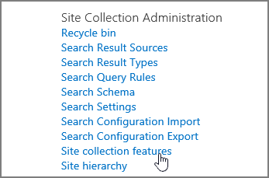

**Note:**A site can be significantly modified in appearance and navigation. If this option isn't available in **Site Settings**, contact your administrator.

1. Do one of the following on each site collection feature you want to enable or disable:
   * Click **Activate** to enable the site collection feature.
   * Click **Deactivate** to disable the site collection feature.

